**Tools Used:**

1. Microsoft Excel -> for converting the given .txt files to csv file
2. MySQL Workbench -> for creating the database, tables, loading the data to the tables from csv files using import wizard option and executing queries.

**SQL Create Statements:**

1. **Creating database**:

create database EmployeeDataManagement;

Screenshot:

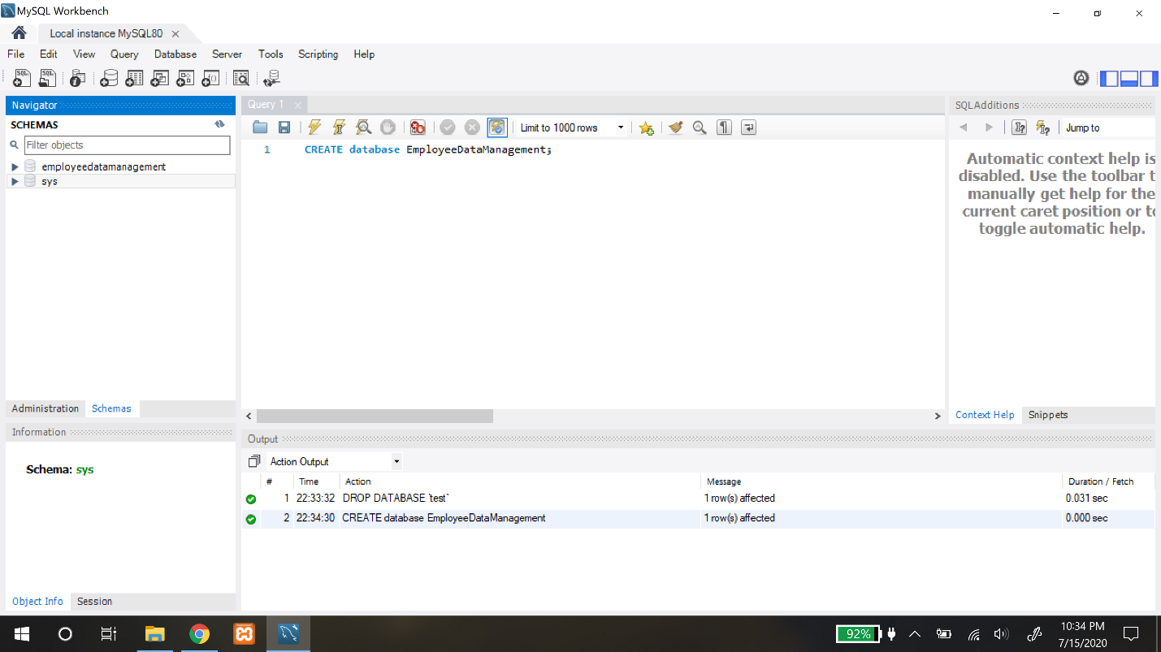

1. **Creating Table statements in the database:**
   1. **Employee Table:**

Create table EMPLOYEE(

Fname varchar(20) not null,

Minit char,

Lname varchar(20) not null,

Ssn char(9),

Bdate date,

Street_address varchar(50),

City varchar(20),

Sex char,

Salary decimal(10,2) not null,

Super_ssn char(9),

Dno int not null,

State varchar(20),

primary key(Ssn)

);

Screenshot:

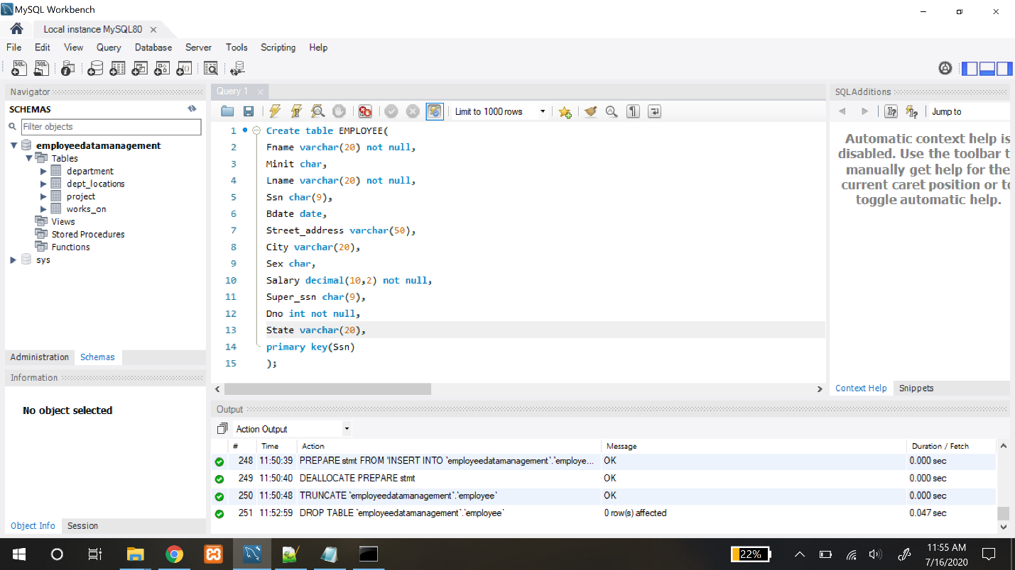

* 1. **DEPARTMENT Table**:

Create table DEPARTMENT(

Dname varchar(20) not null,

Dnumber int not null,

Mgr_ssn char(9) not null,

Mgr_start_date date,

primary key(Dnumber),

unique(Dname)

);

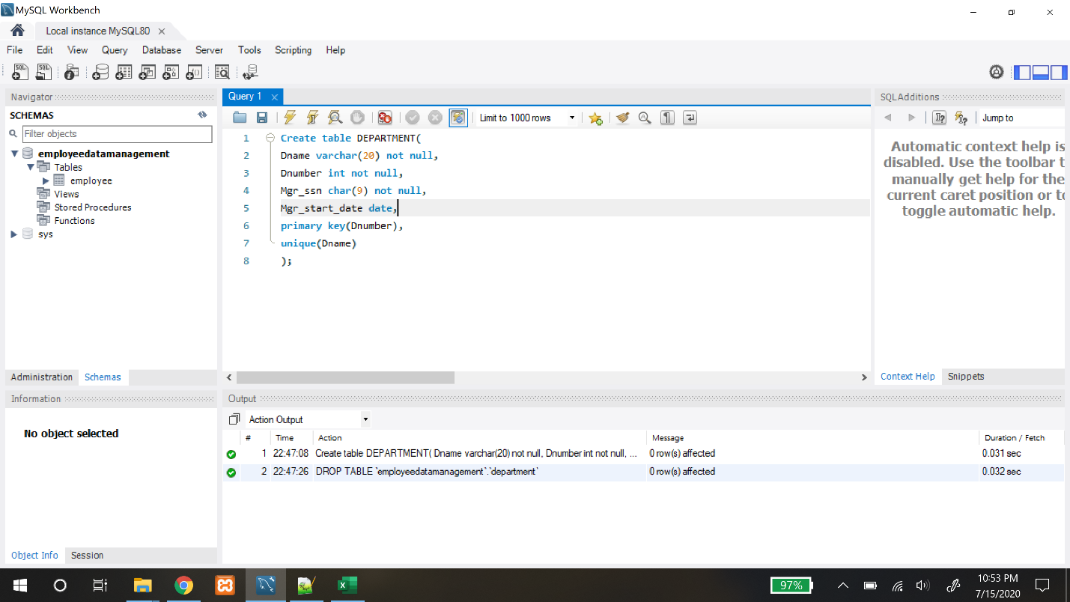

* 1. **DEPT_LOCATIONS Table:**

Create table DEPT_LOCATIONS(

Dnumber int not null,

Dlocation varchar(20) not null,

primary key(Dnumber,Dlocation)

);

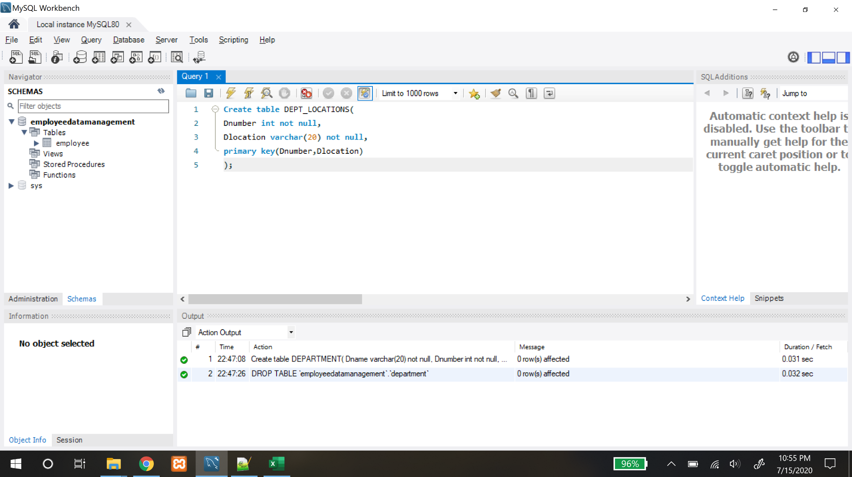

* 1. **PROJECT Table:**

Create table PROJECT(

Pname varchar(20) not null,

Pnumber int not null,

Plocation varchar(20),

Dnum int not null,

primary key(Pnumber),

unique(Pname)

);

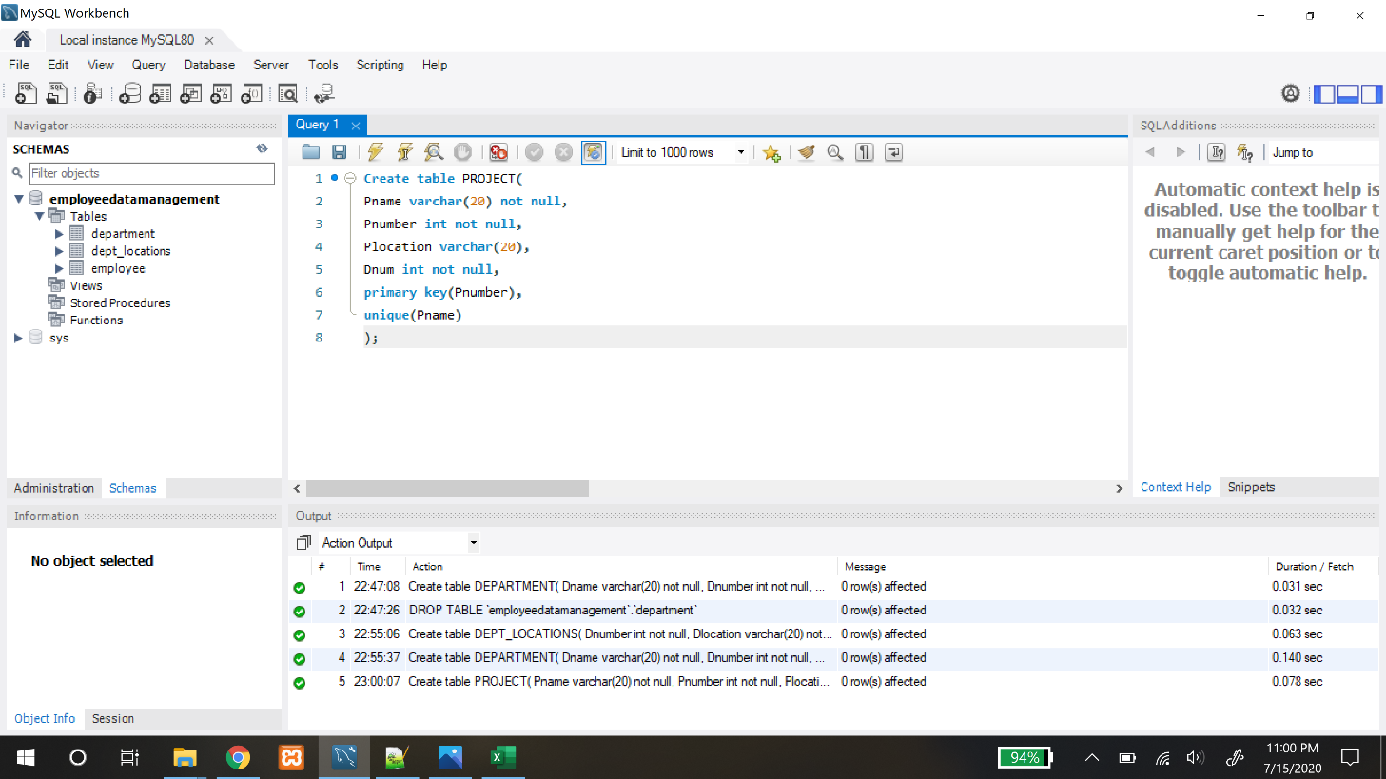

* 1. **WORKS_ON Table:**

Create table WORKS_ON(

Essn char(9) not null,

Pno int not null,

Hours decimal(3,1) not null,

primary key(Essn,Pno)

);

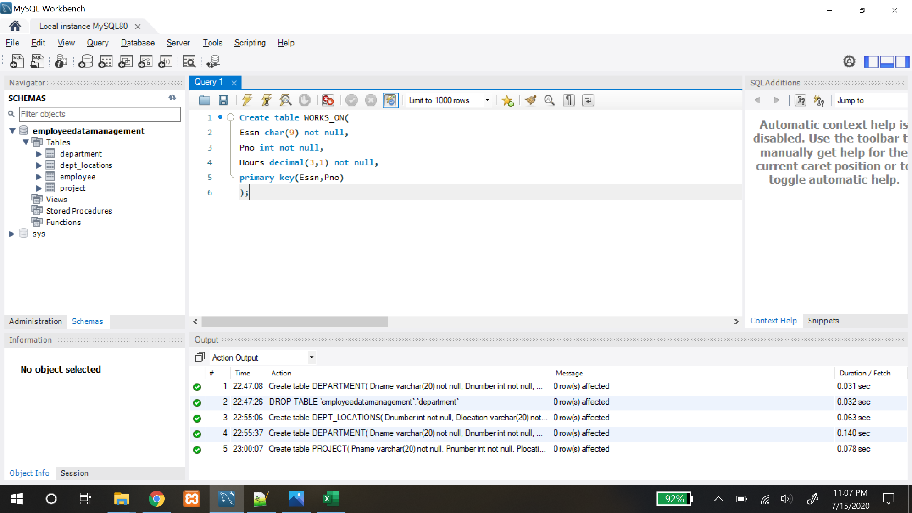

**LOADING DATA TO TABLES:**

We have used Table Data Import Wizard Option from MySQL Workbench tool for loading the data into the respective tables.

Before loading the data tables, we have converted the given text files to csv (Comma Separated Values) files with the help of Microsoft excel tool.

**PROCEDURE: (One way)**

1. Right click on the respective created table.
2. Click on Table Data Import Wizard option from the menu provided.
3. Select the csv file using browse option and click next.
4. Select Destination Table and click next.
5. Check and select source and destination column mapping and click next.
6. Import Data and click next.
7. Data will be successfully loaded into the respective table.

**(Second Way) :- Optional :**

LOAD DATA INFILE '<csv file path>'

INTO TABLE <Table Name> FIELDS TERMINATED BY ','

ENCLOSED BY '"' LINES TERMINATED BY '\n';

**EMPLOYEE TABLE:**

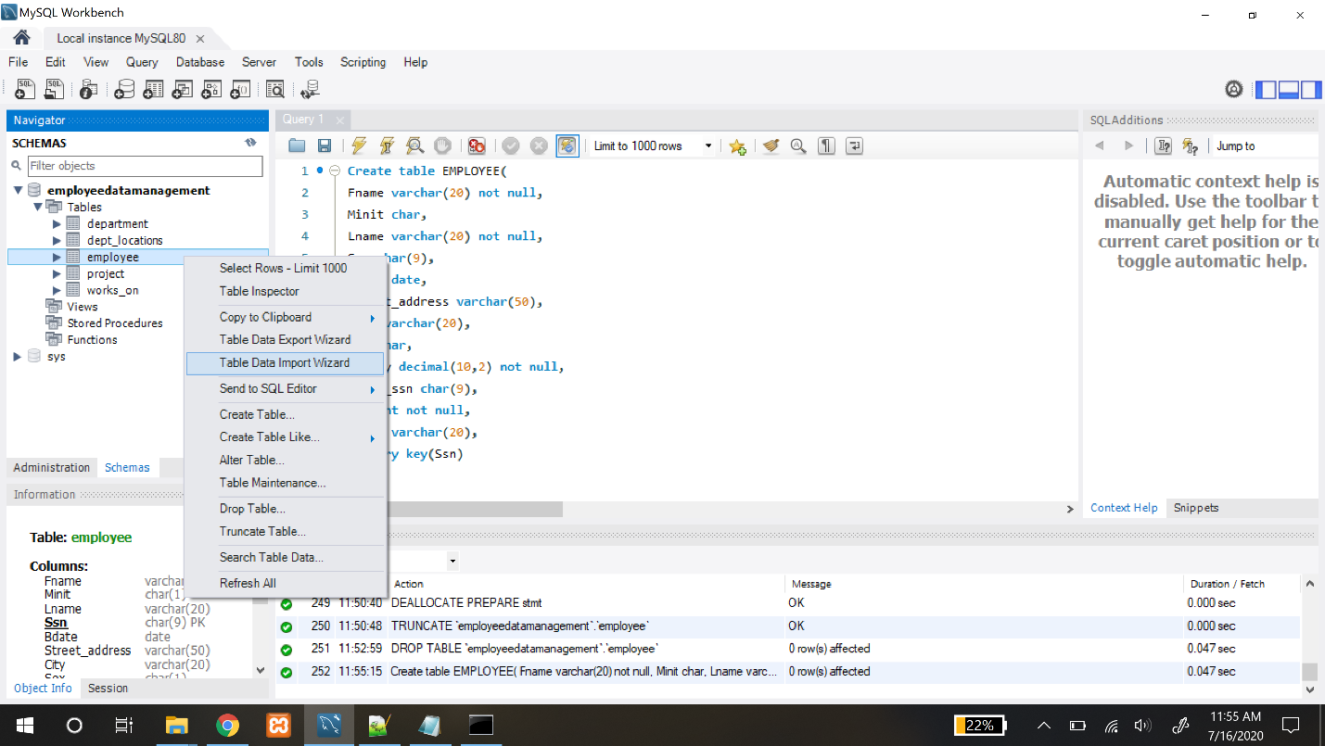

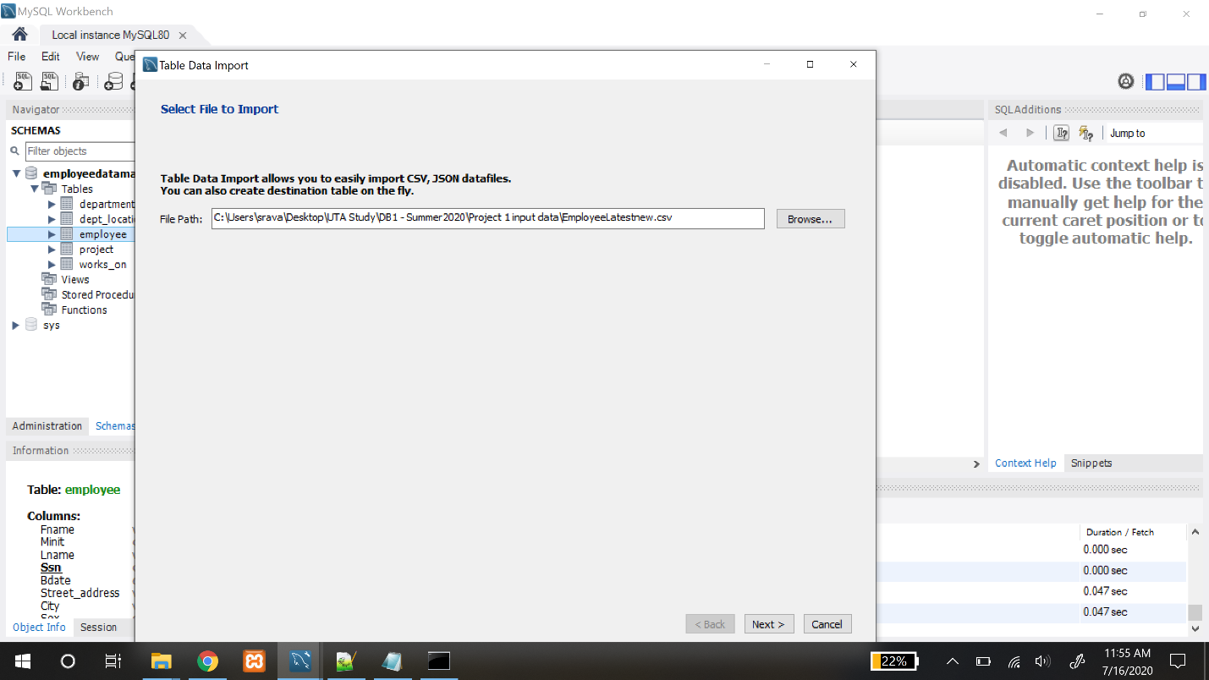

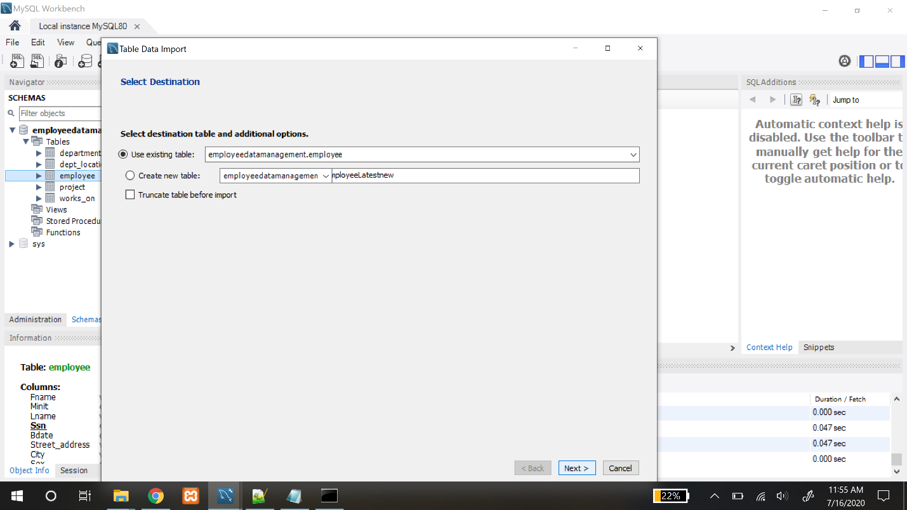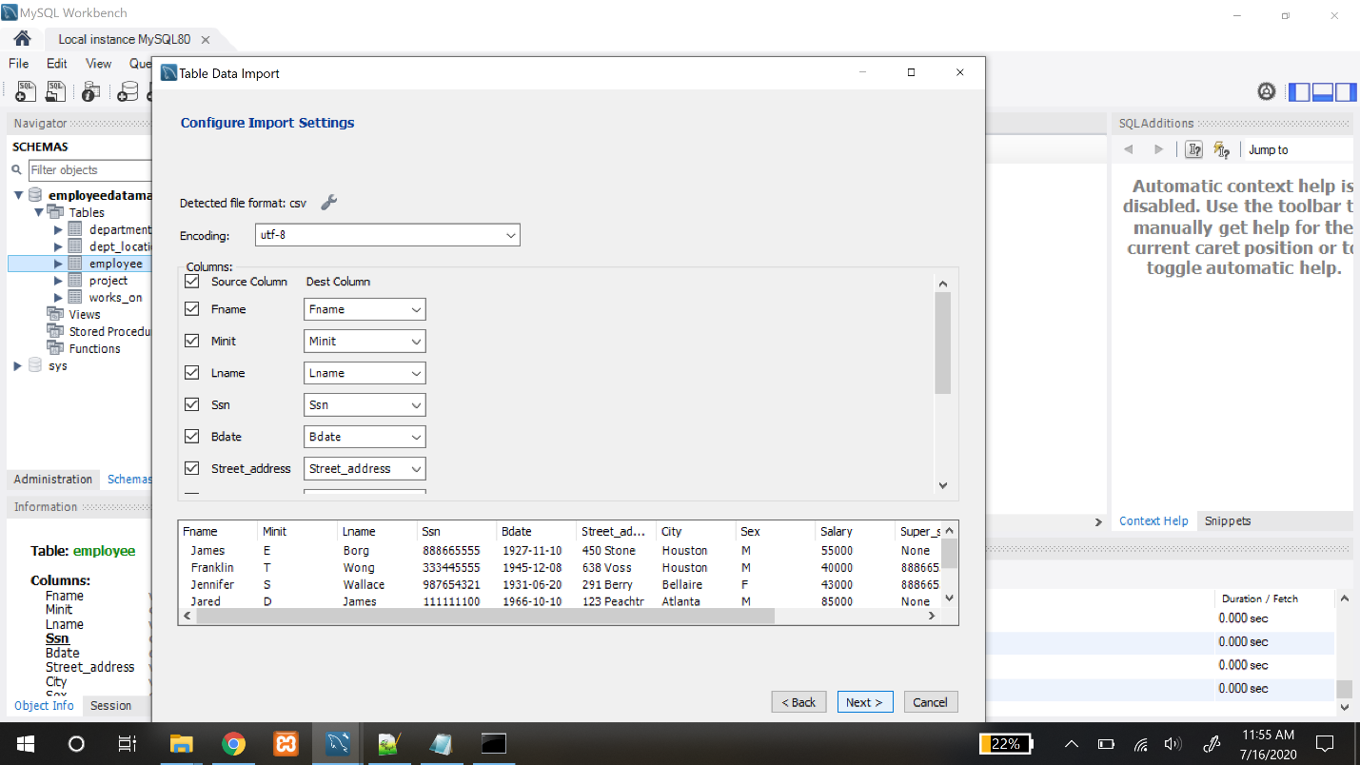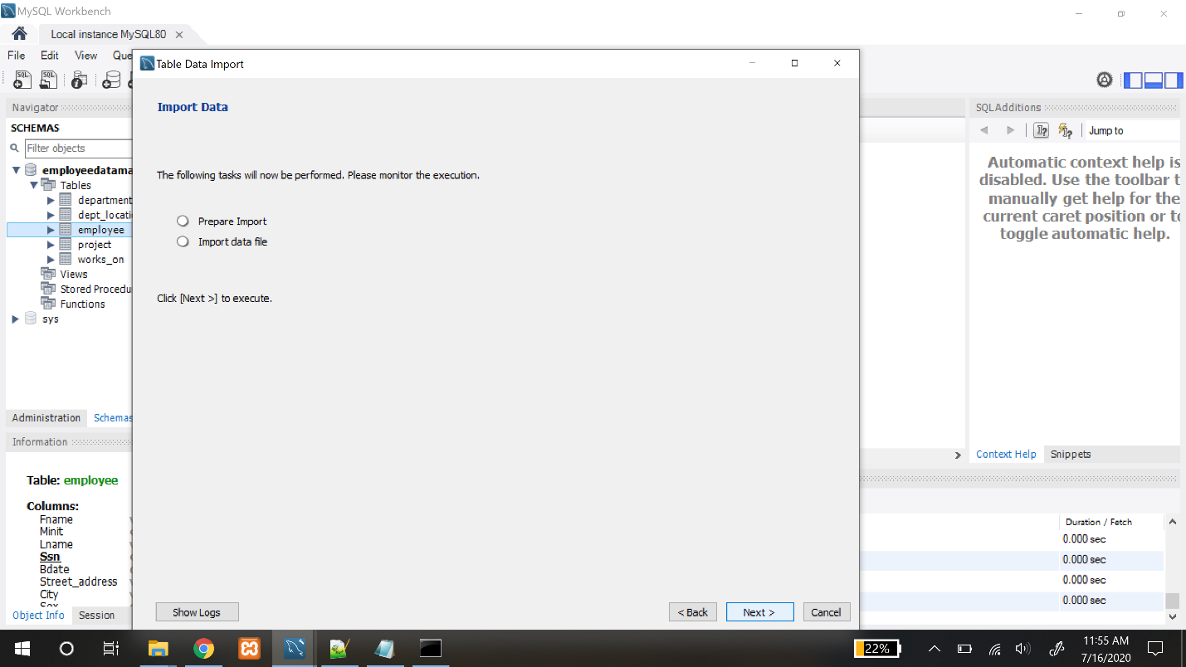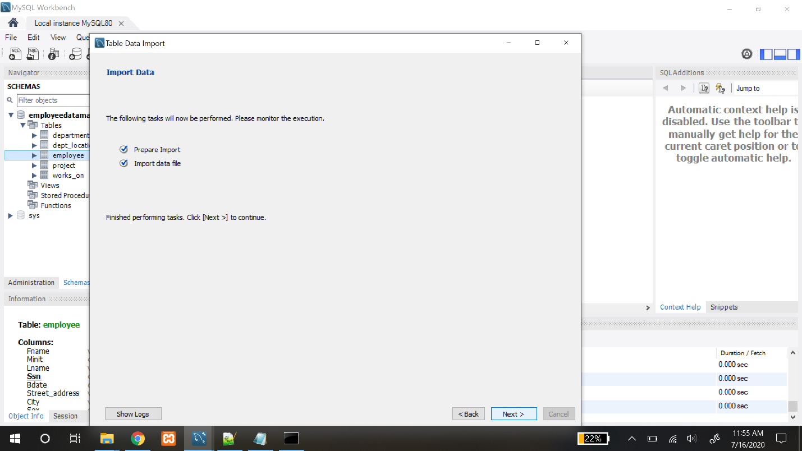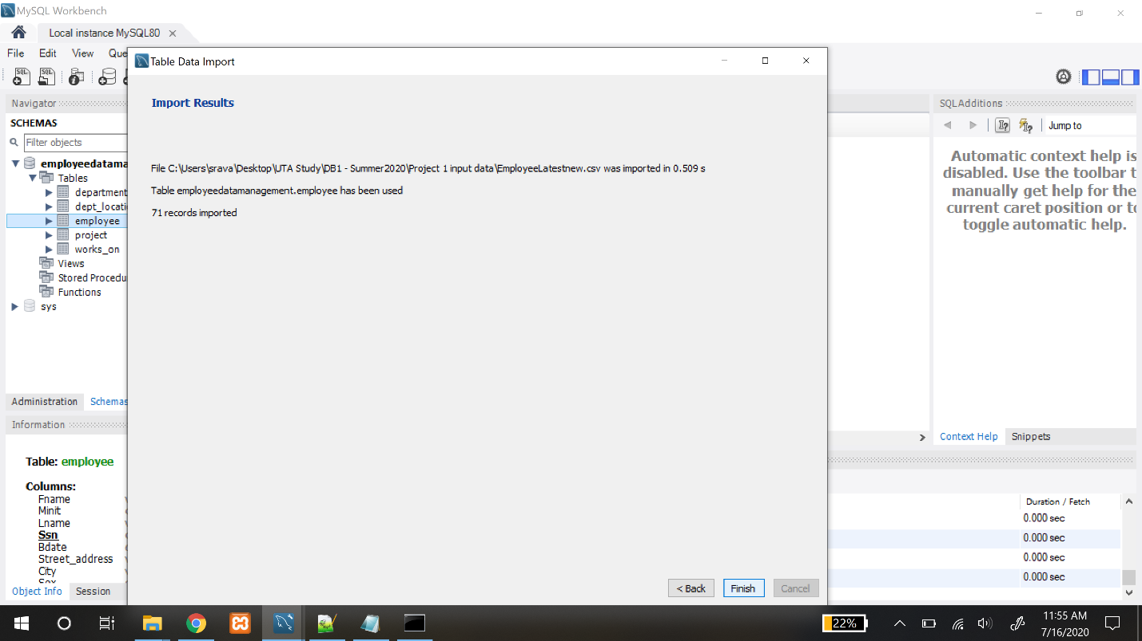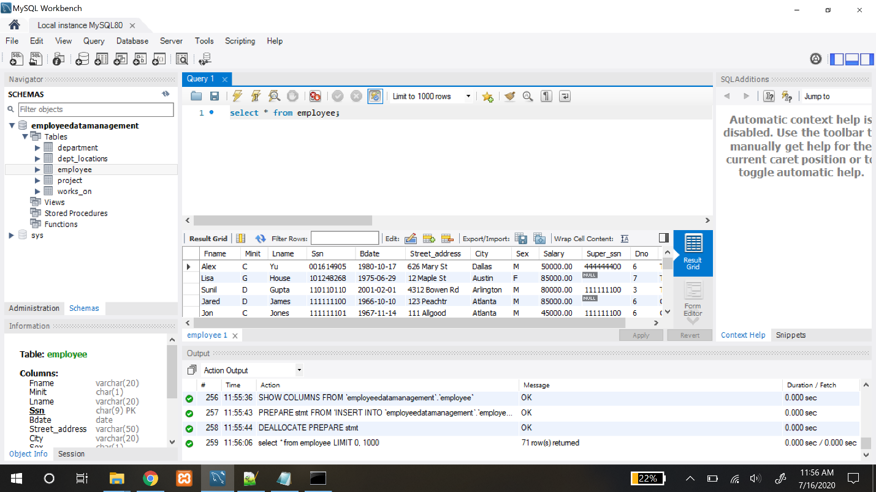

**NOTE: The above listed procedure is followed for all the other tables (department,**

**project, works_on, dept_locations). Please refer to the bottom of the document to see the screen shots of other tables as well.**

**CONFIGURING FOREIGN KEYS:**

Foreign keys are added after loading the data tables to handle the **referential integrity constraints**.

**ALTER TABLE employee**

**ADD CONSTRAINT FK_employee_department**

**FOREIGN KEY (Dno) REFERENCES department(Dnumber);**

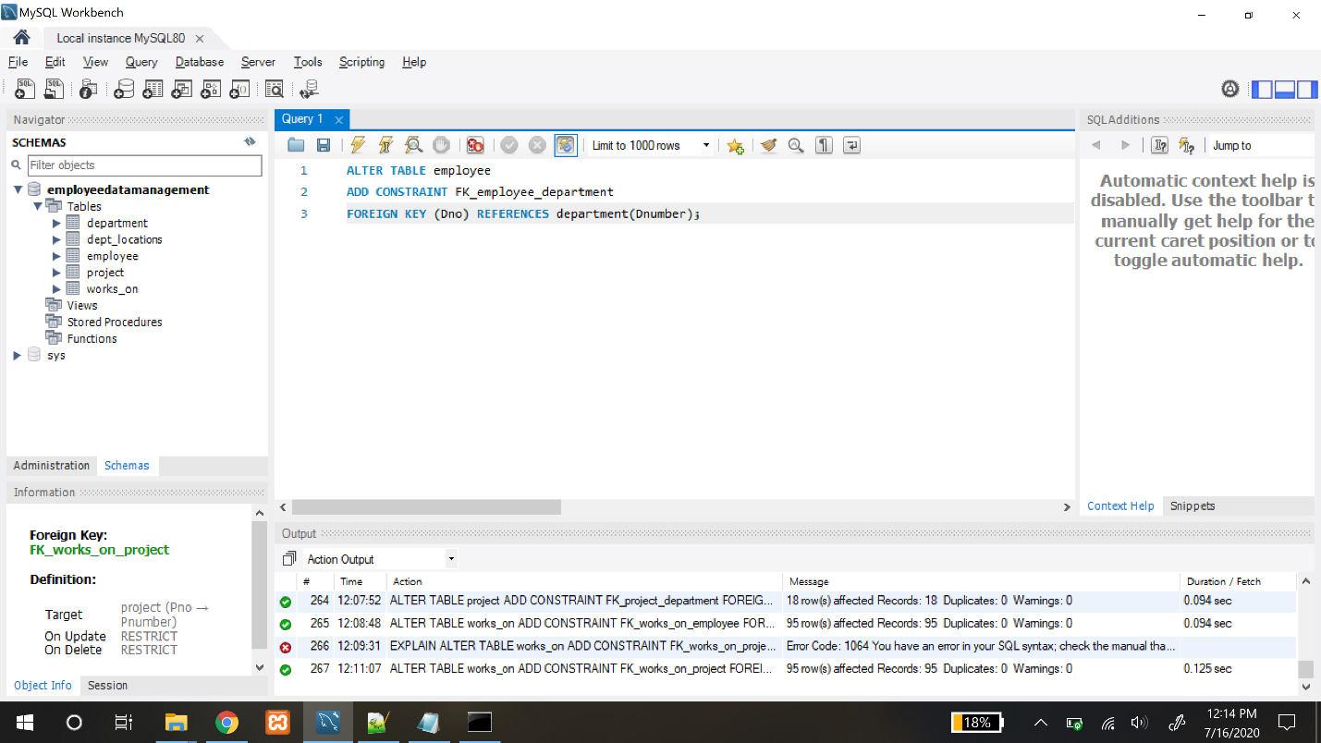

**ALTER TABLE employee**

**ADD CONSTRAINT FK_employee_employee**

**FOREIGN KEY (Super_ssn) REFERENCES employee(Ssn);**

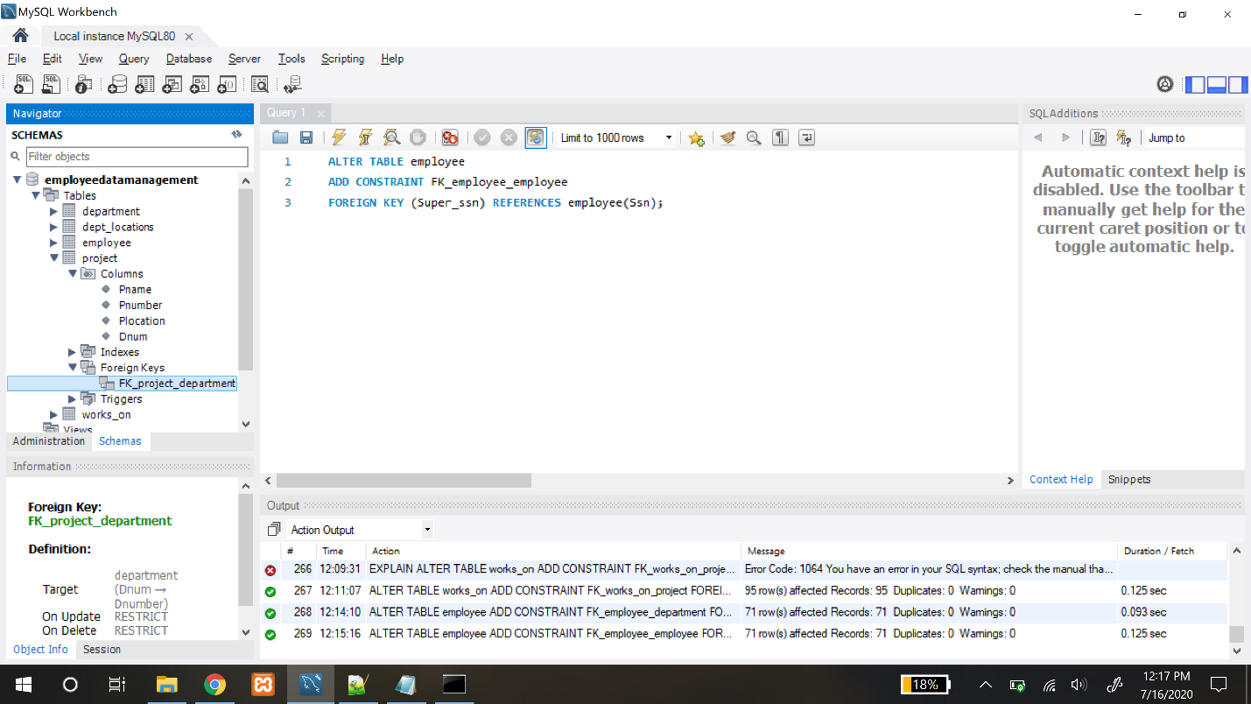

**ALTER TABLE department**

**ADD CONSTRAINT FK_employeedepartment**

**FOREIGN KEY (Mgr_ssn) REFERENCES employee(Ssn);**

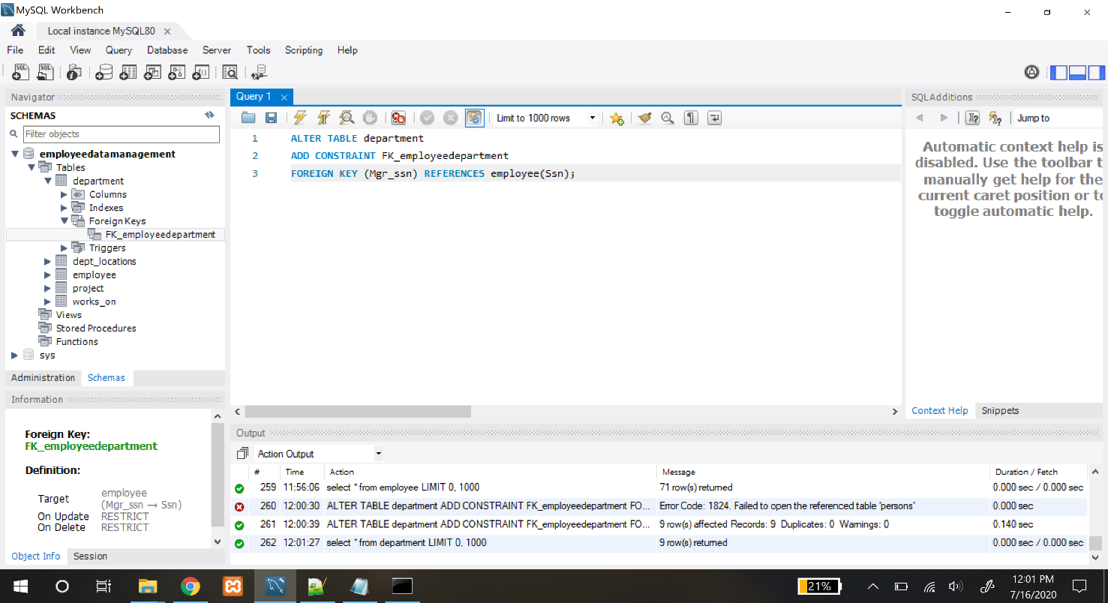

**ALTER TABLE dept_locations**

**ADD CONSTRAINT FK_dept_locations_department**

**FOREIGN KEY (Dnumber) REFERENCES department(Dnumber);**

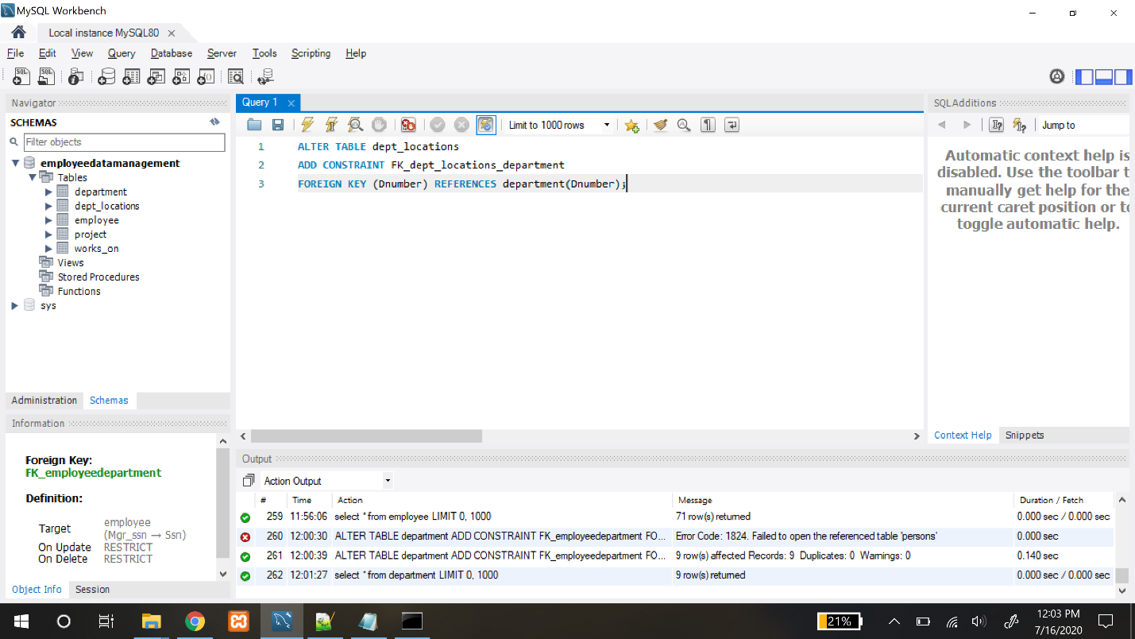

**ALTER TABLE project**

**ADD CONSTRAINT FK_project_department**

**FOREIGN KEY (Dnum) REFERENCES department(Dnumber);**

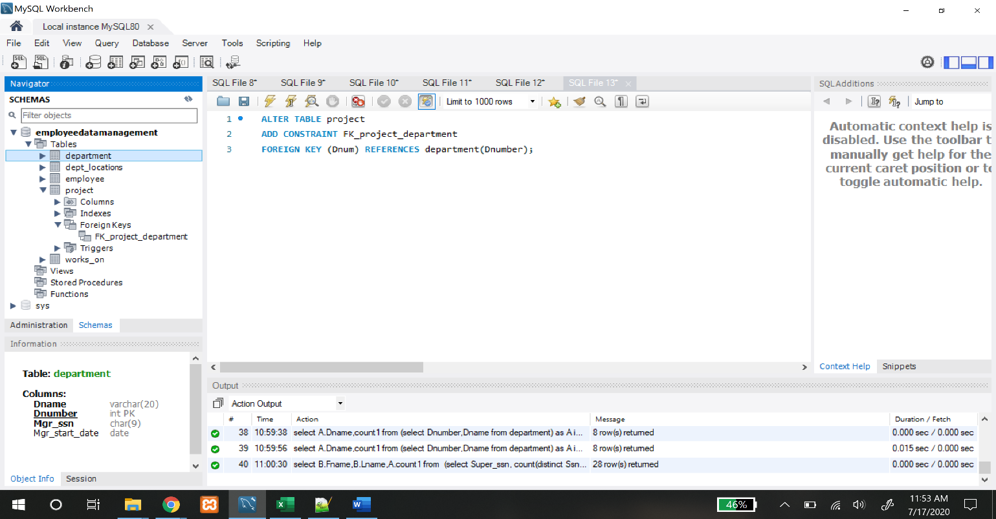

**ALTER TABLE works_on**

**ADD CONSTRAINT FK_works_on_employee**

**FOREIGN KEY (Essn) REFERENCES employee(ssn);**

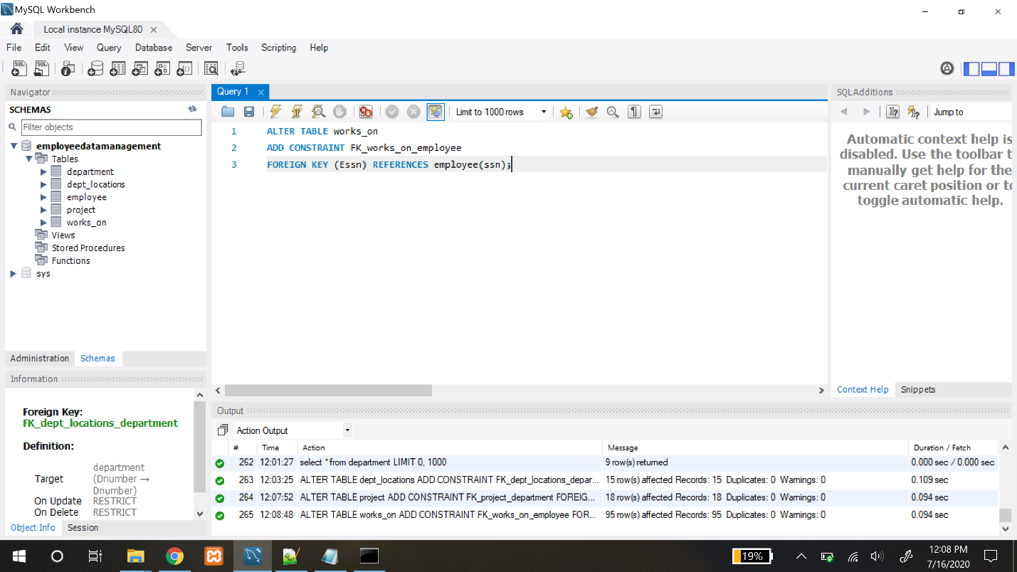

**ALTER TABLE works_on**

**ADD CONSTRAINT FK_works_on_project**

**FOREIGN KEY (Pno) REFERENCES project(Pnumber);**

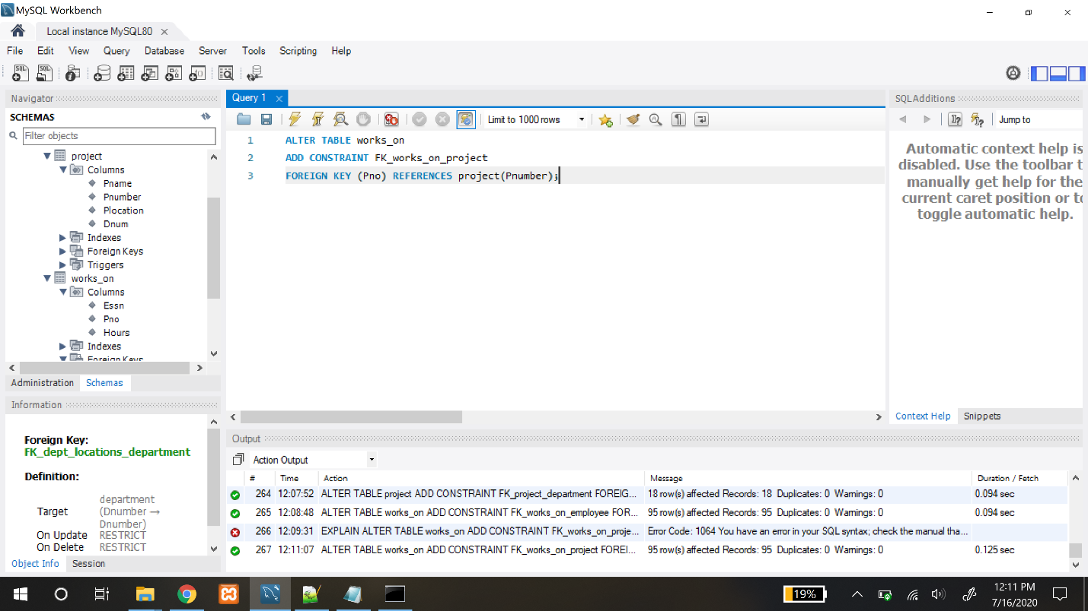

**SQL SELECT STATEMENTS:**

Query 4) Enter a department name and retrieve all the names and salaries of all employees who work in that department.

Method 1:

**select A.Fname,A.Lname,A.Salary from**

**(select Fname,Lname,Dno,Salary from employee) as A**

**inner join**

**(select Dnumber,Dname from department) as B**

**on A.Dno = B.Dnumber**

**where B.Dname="Research";**

|  |  |  |
| --- | --- | --- |
| **Fname** | **Lname** | **Salary** |
| John | Smith | 30000 |
| Franklin | Wong | 40000 |
| Joyce | English | 25000 |
| Andrea | Sondrini | 65000 |
| Michael | Morgan | 73500 |
| Ramesh | Narayan | 38000 |
| James | Miller | 75000 |

Output:

Screenshot:

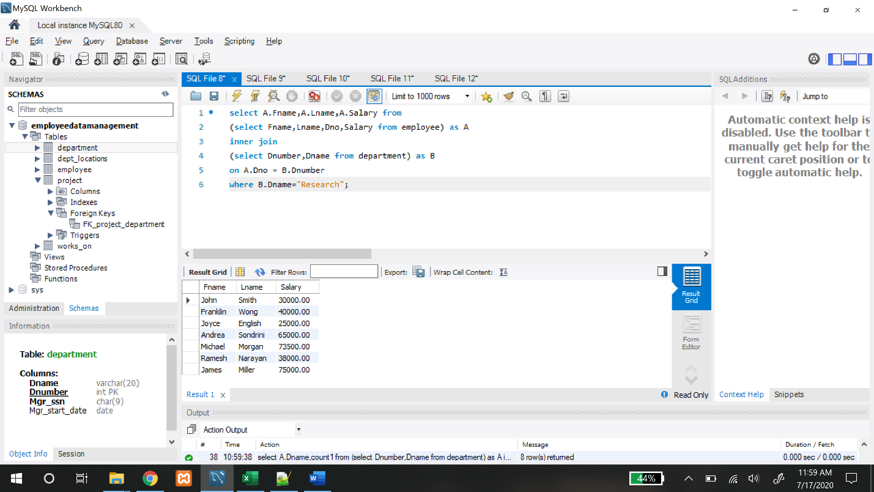

Method 2:

**SELECT Fname,Lname,Salary FROM employee,department**

**WHERE Dname="Research" AND Dnumber=Dno;**

Output:

|  |  |  |
| --- | --- | --- |
| **Fname** | **Lname** | **Salary** |
| John | Smith | 30000 |
| Franklin | Wong | 40000 |
| Joyce | English | 25000 |
| Andrea | Sondrini | 65000 |
| Michael | Morgan | 73500 |
| Ramesh | Narayan | 38000 |
| James | Miller | 75000 |

Screenshot:

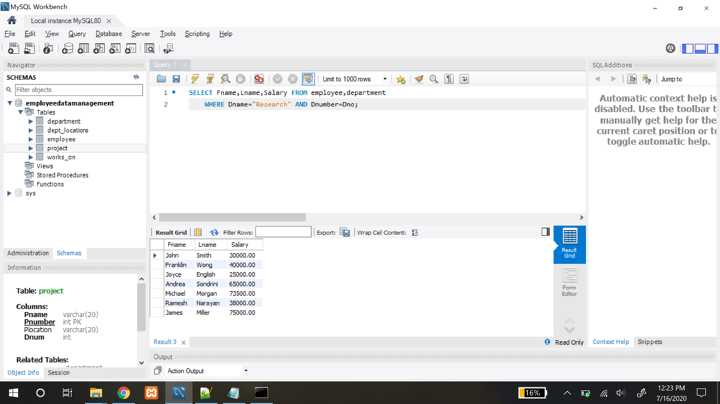

Query 5) Enter an employee last name and first name and retrieve a list of projects names/hours per week that the employee works on.

Method 1:

**select C.Pname, B.Hours from**

**(select Fname,Lname,Ssn from employee) as A**

**inner join**

**(select Hours, Essn, Pno from works_on) as B on A.Ssn=B.Essn**

**inner join**

**(select Pname,Pnumber from project) as C on B.Pno = C.Pnumber**

**Where A.Fname="John" AND A.Lname="Smith";**

Output:

|  |  |
| --- | --- |
| **Pname** | **Hours** |
| ProductX | 32.5 |
| ProductY | 7.5 |

Screenshot:

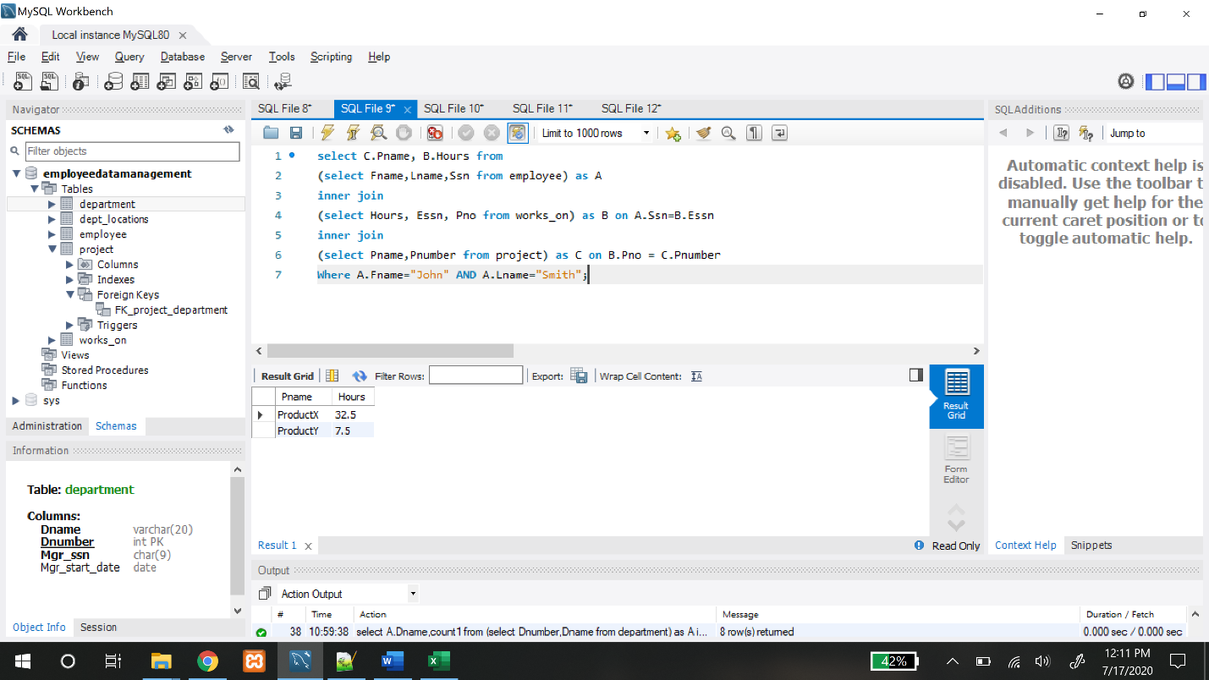

Method 2:

**SELECT Pname,Hours FROM project,works_on,employee**

**WHERE Fname="John" AND Lname="Smith" AND**

**Pnumber=Pno AND Essn=Ssn;**

Output:

|  |  |
| --- | --- |
| **Pname** | **Hours** |
| ProductX | 32.5 |
| ProductY | 7.5 |

Screenshot:

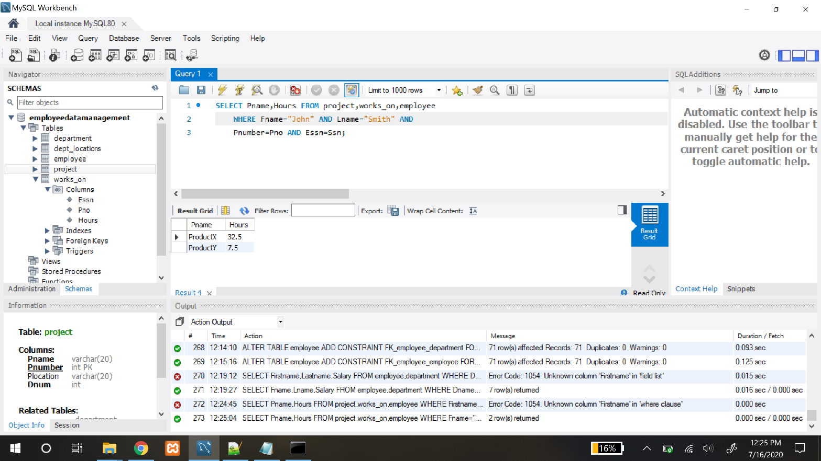

Query 6) **Enter a department name and retrieve the total of all employee salaries who work in the department.**

Method 1:

**select Salary from**

**(select Dname,Dnumber from department) as A**

**inner join**

**(select Dno,sum(Salary) as Salary from employee group by Dno) as B**

**on A.Dnumber = B.Dno and A.Dname="Software";**

Output:

|  |
| --- |
| **Salary** |
| 758000 |

Screenshot:

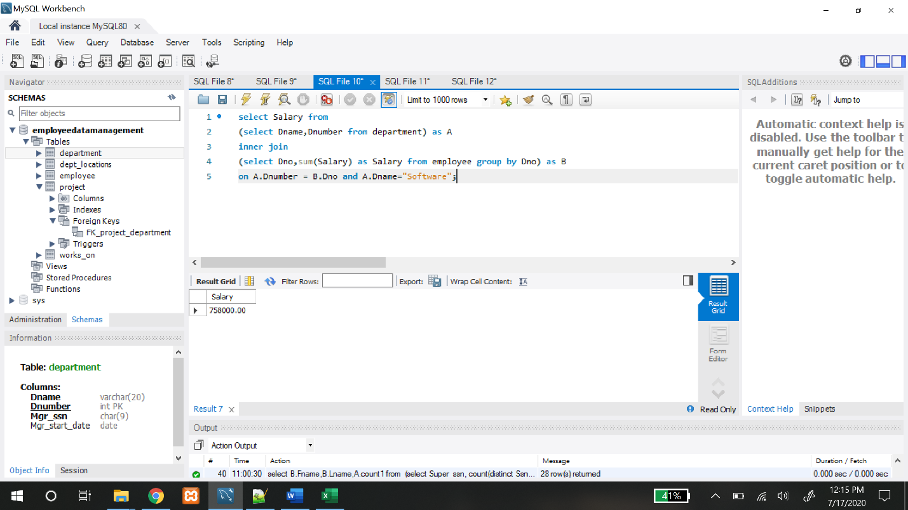

Method 2:

**SELECT Dnumber,Dname,SUM(Salary) FROM employee, department**

**WHERE Dnumber=Dno AND Dname = "Software";**

Output:

|  |  |  |  |  |  |  |
| --- | --- | --- | --- | --- | --- | --- |
| |  |  |  | | --- | --- | --- | | **Dnumber** | **Dname** | **SUM(Salary)** | | 6 | Software | 758000 | |
|  |
|  |
|  |

Screenshot:

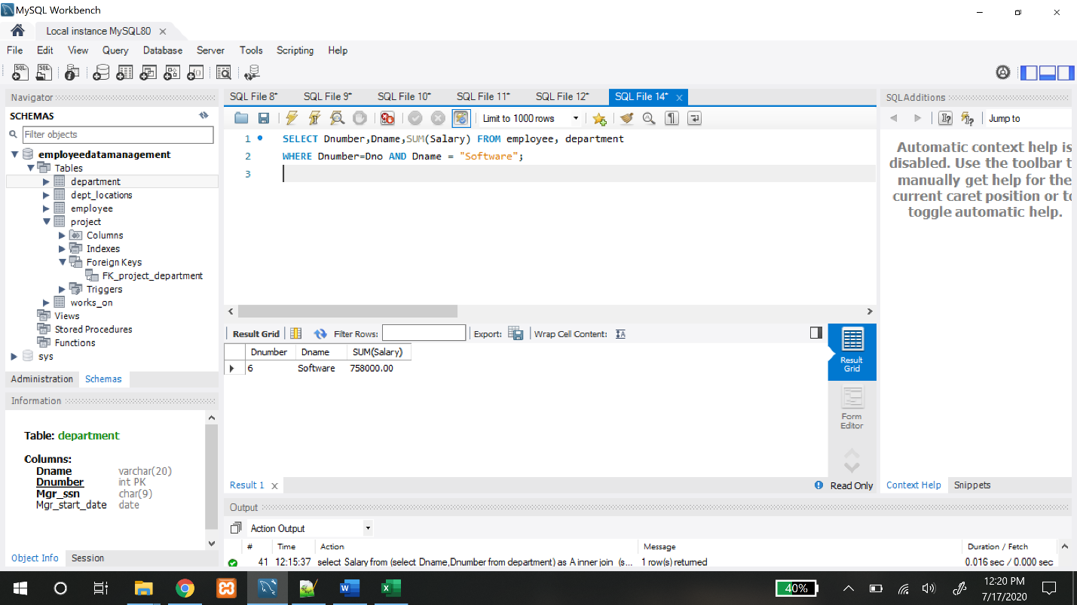

Query 7) **For each department, retrieve the department name and the number (count) of employees who work in that department. Order the result by number of employees in descending order.**

Method 1:

**select A.Dname,count1 as NumberOfEmployees from**

**(select Dnumber,Dname from department) as A**

**left join**

**(select Dno,count(Ssn) as count1 from employee group by Dno) as B**

**on A.Dnumber = B.Dno**

**order by count1 desc;**

Output:

|  |  |
| --- | --- |
| Dname | NumberOfEmployees |
| Sales | 18 |
| Software | 16 |
| Hardware | 14 |
| HR | 7 |
| Research | 7 |
| Administration | 6 |
| Headquarters | 2 |
| Networking | 1 |
| QA | NULL |

Screenshot:

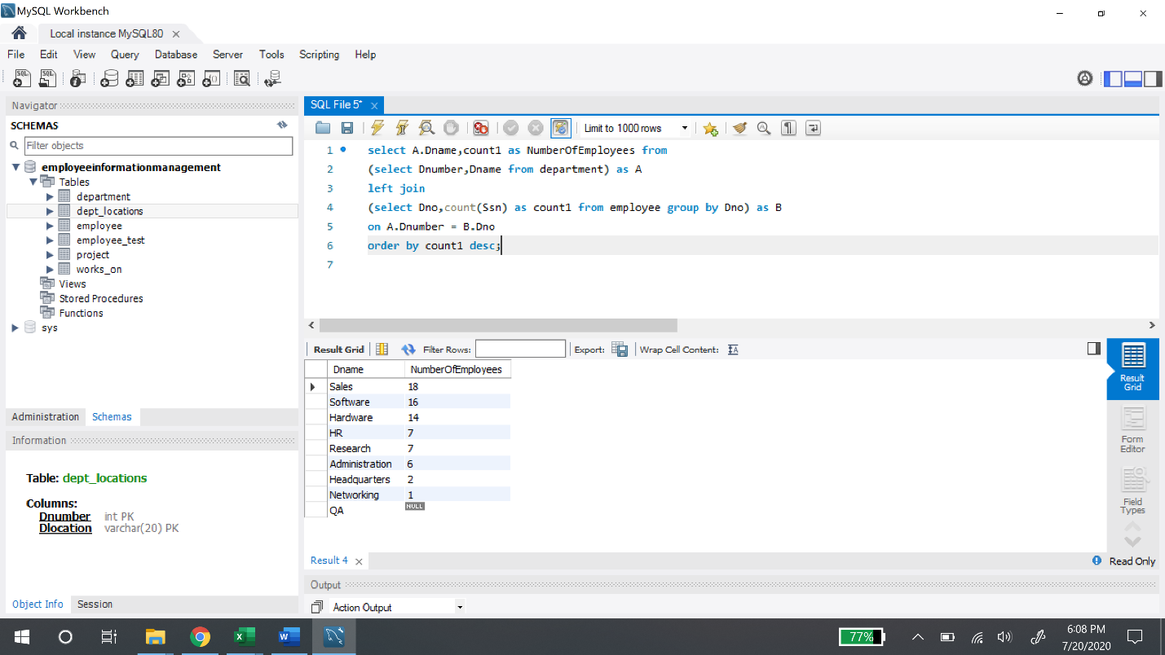

Method 2:

**SELECT Dname, COUNT(*) AS Number_of_employees**

**FROM DEPARTMENT,EMPLOYEE**

**WHERE Dnumber=Dno**

**GROUP BY Dname**

**ORDER BY COUNT(*) DESC;**

Output:

|  |  |
| --- | --- |
| **Dname** | **Number_of_employees** |
| Sales | 18 |
| Software | 16 |
| Hardware | 14 |
| HR | 7 |
| Research | 7 |
| Administration | 6 |
| Headquarters | 2 |
| Networking | 1 |

Screenshot:

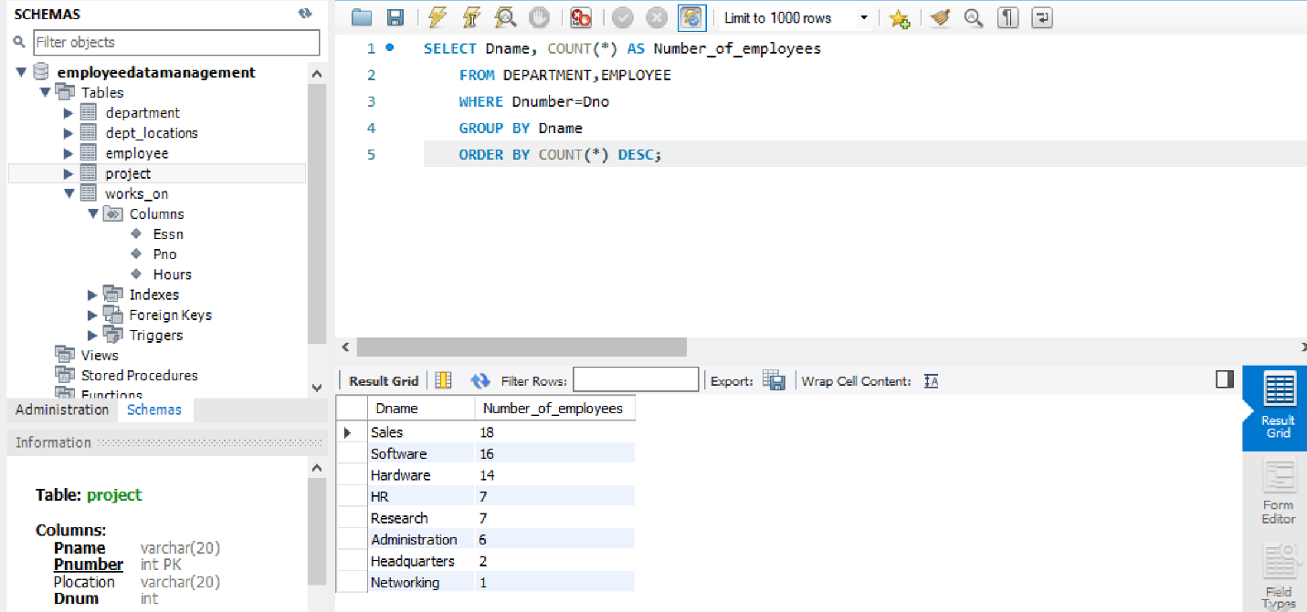

Query 8) **For each employee who is a supervisor, retrieve the employee first and last name and the number (count) of employees that are supervised. Order the result in descending order.**

**select B.Fname,B.Lname,A.count1 as Number_of_employees_supervised from**

**(select Super_ssn, count(distinct Ssn) as count1 from employee group by Super_ssn) as A**

**inner join**

**(select distinct Fname,Lname,Ssn from employee) As B**

**on A.Super_ssn = B.ssn**

**order by count1 desc;**

Output:

|  |  |  |
| --- | --- | --- |
| **Fname** | **Lname** | **Number_of_employees_supervised** |
| Alex | Freed | 7 |
| Jared | James | 4 |
| Bob | Bender | 4 |
| Roy | Lewallen | 4 |
| Evan | Wallis | 3 |
| Franklin | Wong | 3 |
| John | James | 3 |
| Kate | King | 3 |
| James | Borg | 3 |
| Juan | Linda | 2 |
| Josh | Zell | 2 |
| Nandita | Ball | 2 |
| Lyle | Leslie | 2 |
| Sammy | Hall | 2 |
| Red | Bacher | 2 |
| Jennifer | Wallace | 2 |
| John | Smith | 1 |
| John | Ed | 1 |
| Kim | Grace | 1 |
| Bonnie | Bays | 1 |
| Alec | Best | 1 |
| Sam | Snedden | 1 |
| Jill | Jarvis | 1 |
| Billie | King | 1 |
| Gerald | Small | 1 |
| Naveen | Drew | 1 |
| Carl | Reedy | 1 |
| Ahmad | Jabbar | 1 |

Screenshot:

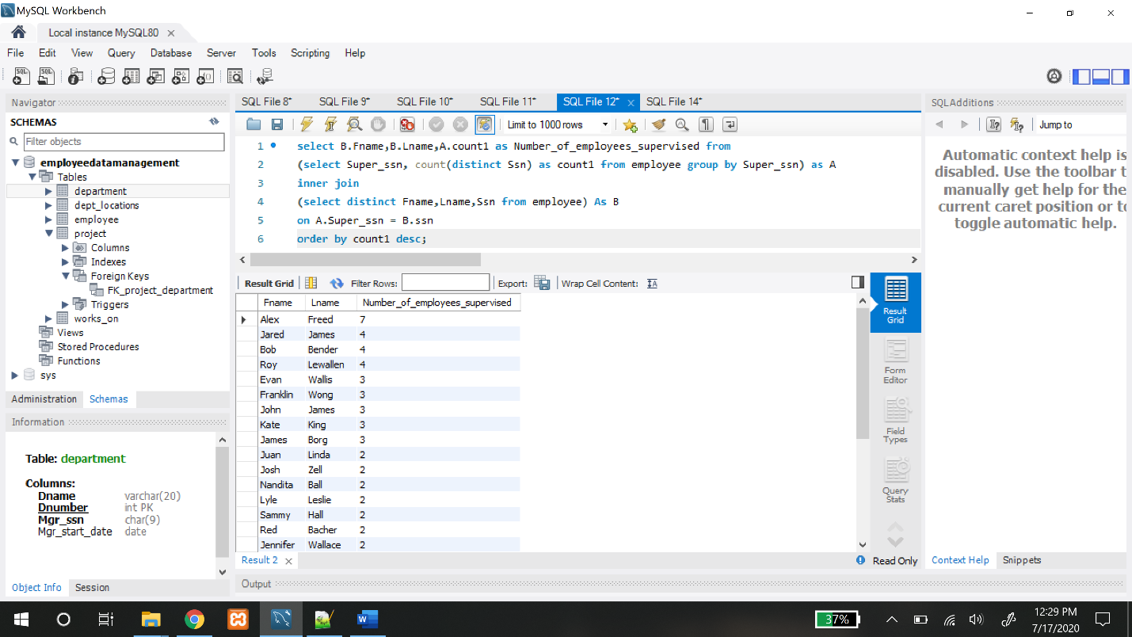

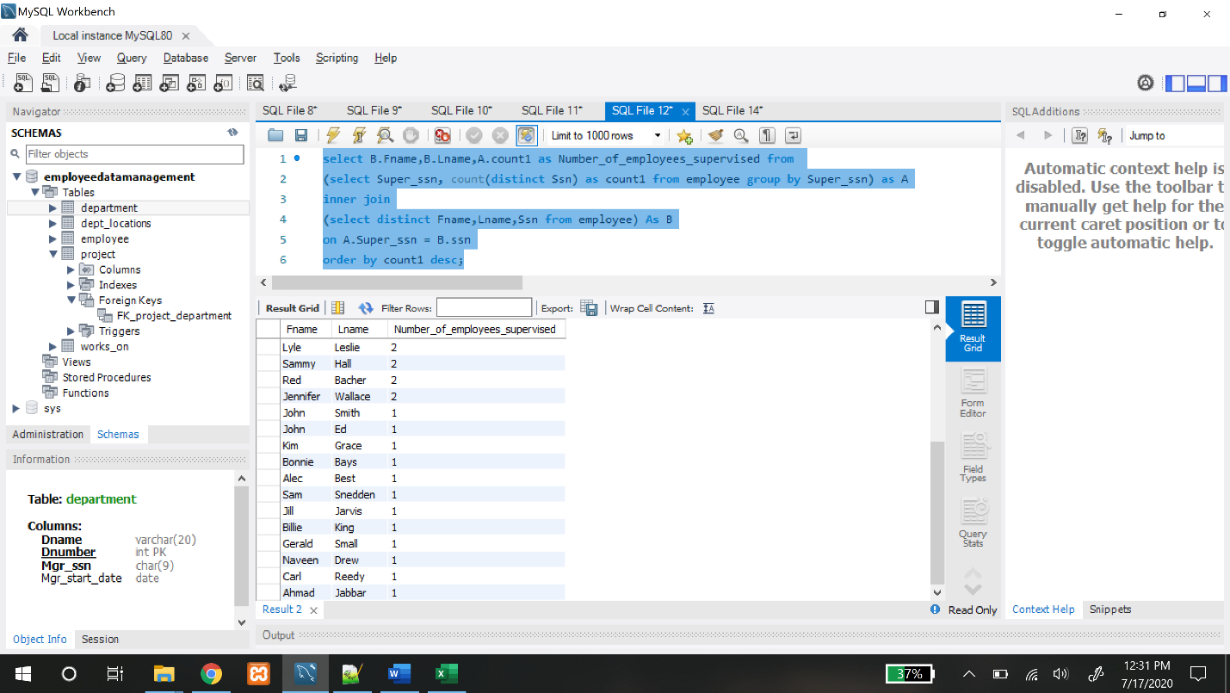

**TASK ASSIGNED:**

Both the team members worked on all aspects of the project.

**Loading Part of other tables: (Attaching Screenshots)**

